Nested try-catch example
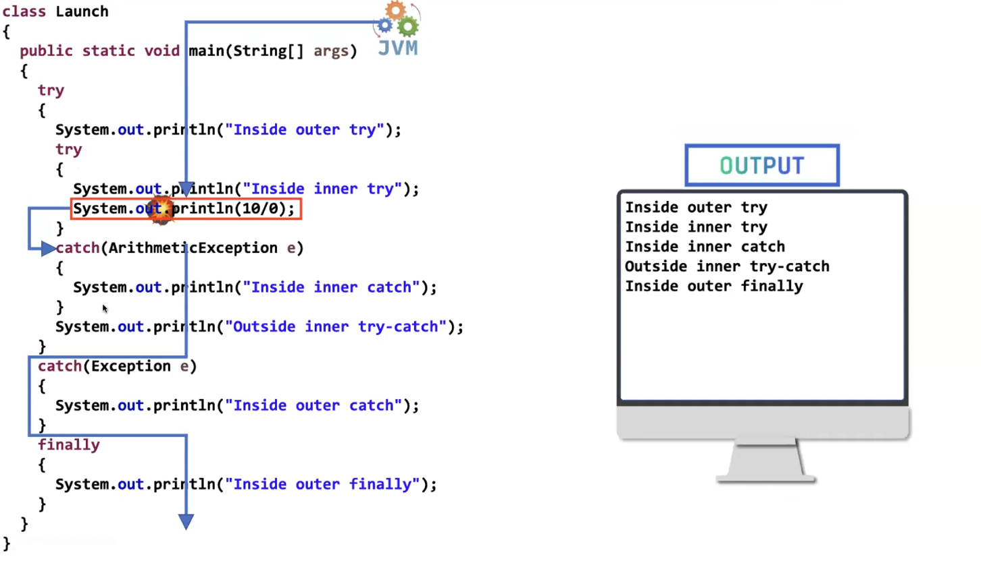

✅ Correct Definition of Partially Checked Exception
Your statement:
It is such a parent Exception class where its child consists of both checked and unchecked exception classes.
✔ This is almost correct.
Let me refine it professionally:
🔹 Correct Definition
A Partially Checked Exception is:
A parent exception class whose subclasses include both checked and unchecked exceptions.
In Java, the only class that fits this definition is:
java.lang.Exception

🔍 Why is Exception Partially Checked?
Because:
Throwable
└── Exception ← Partially Checked
├── RuntimeException ← Unchecked
└── IOException ← Checked
So:
- Some children are checked
- Some children are unchecked
That’s why Exception is called partially checked.

❌ Now the Important Correction
You wrote:
If it is a partially checked exception it should be handled compulsorily
This statement needs correction.
🔴 Correct Rule:
If you directly use Exception, it must be handled or declared.
Example:
void test() throws Exception
Compiler forces handling.
Why?
Because Exception may represent a checked exception.

But Important Clarification
Not every subclass of Exception must be handled.
For example:
NullPointerException
This extends:
RuntimeException → Exception
But it is unchecked, so:
✔ No compulsory handling.

🎯 Final Correct Understanding
Type | Must Handle?
Exception (parent) | ✅ Yes
Checked exceptions (like IOException) | ✅ Yes
RuntimeException | ❌ No
Error | ❌ No

🧠 Interview-Level Explanation (Short Version)
Exception is called partially checked because it has both checked and unchecked subclasses.
When declared directly, it must be handled because it may represent a checked exception.

🔥 Final Corrected Statement (You Can Write This)
A partially checked exception is a parent exception class whose subclasses include both checked and unchecked exceptions. In Java, Exception is partially checked. When used directly, it must be handled or declared because it may represent a checked exception.

If you want, I can now give:
- 🔥 5 tricky interview questions on this
- 🔥 Memory trick to never forget this
- 🔥 Code examples showing compiler behavior
Tell me what you want next 💪
We can write another try-catch in “inside inner try”. Similarly we can write another try catch in “inside inner catch”. Even in the finally block also we can write try-catch. We can write any number of times nested try - catch there is no restriction.
Good topic Pavan 🔥
This is called Nested try–catch.
Your statements are mostly correct ✅
Let’s make them 100% technically accurate + interview ready.

✅ 1️⃣ Can we write try–catch inside another try?
✔ YES.
Example:
class NestedTryDemo {
public static void main(String[] args) {
try {
System.out.println("Outer try started");
try {
int a = 10 / 0; // ArithmeticException
}
catch (ArithmeticException e) {
System.out.println("Inner catch handled: " + e);
}
System.out.println("Outer try continues");
}
catch (Exception e) {
System.out.println("Outer catch handled: " + e);
}
System.out.println("Program ends");
}
}
✔ Inner exception handled by inner catch
✔ Outer catch not executed

✅ 2️⃣ Can we write try–catch inside catch block?
✔ YES.
Example:
class TryInsideCatch {
public static void main(String[] args) {
try {
int a = 10 / 0; // ArithmeticException
}
catch (ArithmeticException e) {
System.out.println("Outer catch executed");
try {
String s = null;
System.out.println(s.length()); // NullPointerException
}
catch (NullPointerException ex) {
System.out.println("Inner catch inside catch handled: " + ex);
}
}
}
}
✔ Completely valid.

✅ 3️⃣ Can we write try–catch inside finally block?
✔ YES.
Example:
class TryInsideFinally {
public static void main(String[] args) {
try {
int a = 10 / 0;
}
catch (ArithmeticException e) {
System.out.println("Handled arithmetic exception");
}
finally {
try {
String s = null;
System.out.println(s.length());
}
catch (NullPointerException e) {
System.out.println("Handled exception inside finally");
}
System.out.println("Finally block executed");
}
}
}
✔ Allowed
✔ Works fine

✅ 4️⃣ Can we write unlimited nested try–catch?
✔ YES.
There is no restriction in Java language.
But ⚠ Important:
Just because we can, doesn't mean we should.
Deep nesting:
- Reduces readability
- Makes debugging hard
- Not recommended in real projects

🧠 Important Execution Rule
When exception occurs:
- JVM first checks current try block
- If not handled → moves to outer try
- If still not handled → JVM default handler
This is called:
👉 Exception Propagation

🎯 Interview-Ready Correct Statement
You can write nested try–catch blocks inside:
- try
- catch
- finally
There is no language restriction on nesting depth.
However, excessive nesting is discouraged because it reduces readability and maintainability.

⚠ Important Caution
If you write:
try {
// some code
}
finally {
// no catch
}
This is valid.
But:
finally {
try {
}
}
Is also valid.
But:
try {
}
Alone is NOT valid.
Must have:
- catch
OR
- finally

🔥 Industry Reality
In real Spring Boot projects:
Deep nested try–catch is avoided.
Instead we use:
- Global exception handling
- @ControllerAdvice
- Custom exceptions

